19F-0228

Muhammad Zain

Remote Sensing

Mid 1-2023

Q1: Working on Shapefiles.

1. Convert and display the dataset of Model Town based-on Land use field.

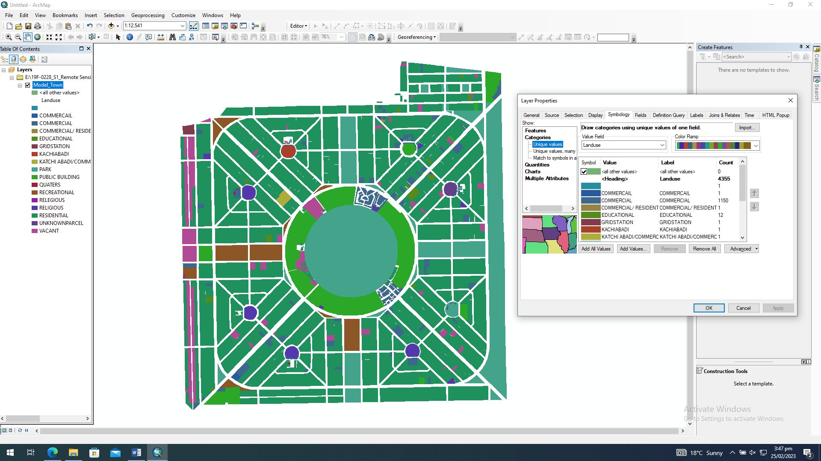

1. Filter the plot size of 3 Marla and 3 Kanal which falls in the commercial area.

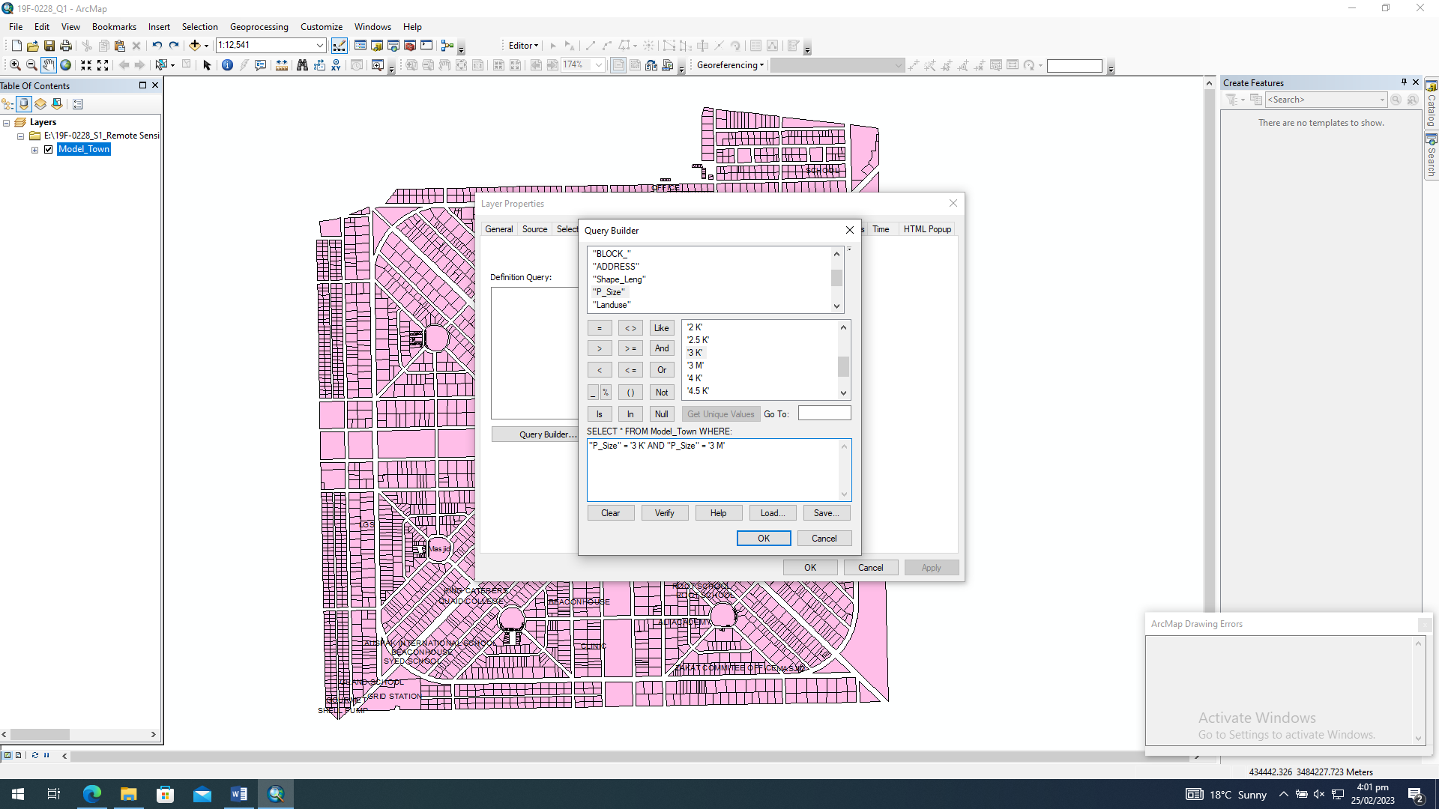

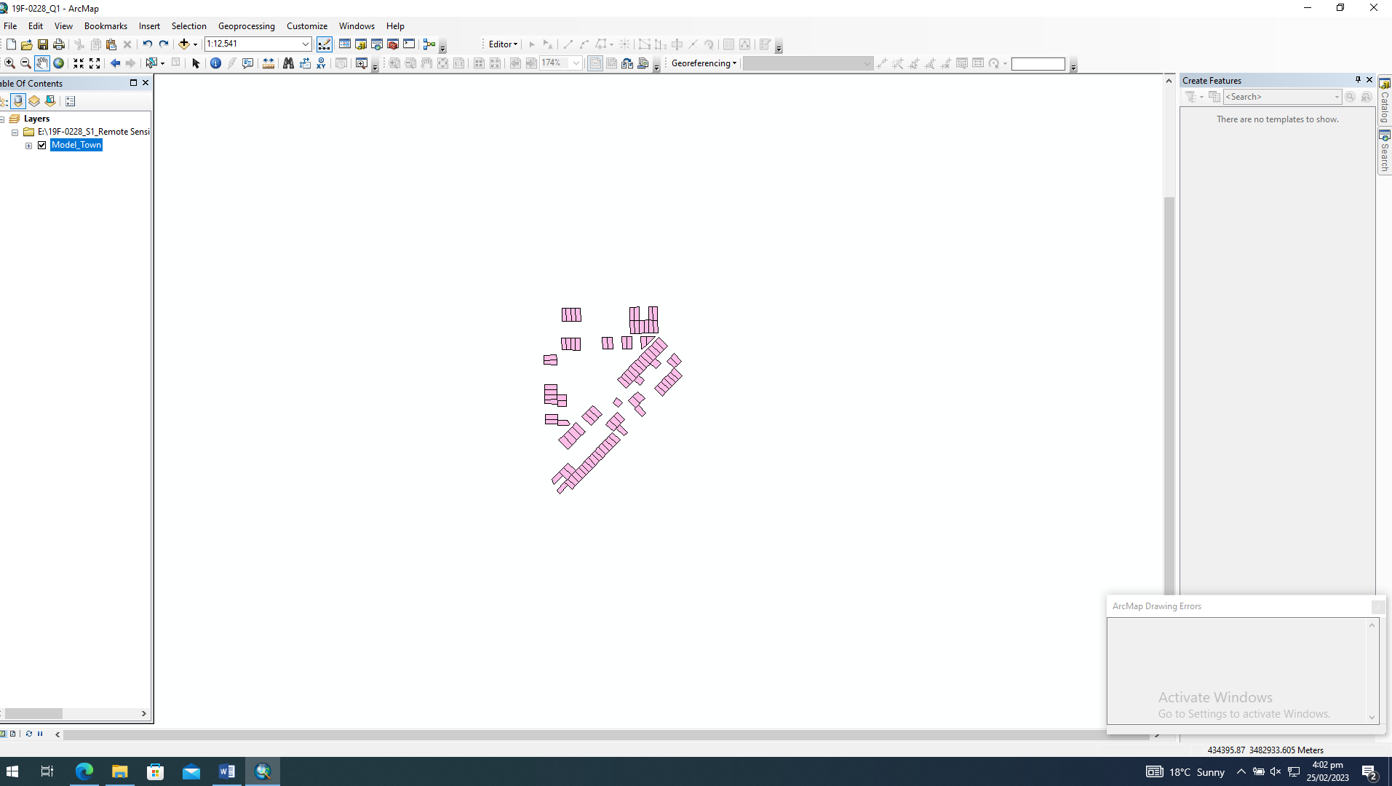

1. Select a suitable commercial land in the Model Town area for FAST-Campus and store it in the attribute table. Display the selected location on the map and label it.
2. Identify the educational places in the Model Town using attribute query.
3. Export your results of the last query in pdf format and your output must have all components of the map.

Q2: Importing Data to ArcMap using FAST-NUCES Students CSV file.

# Importing CSV file

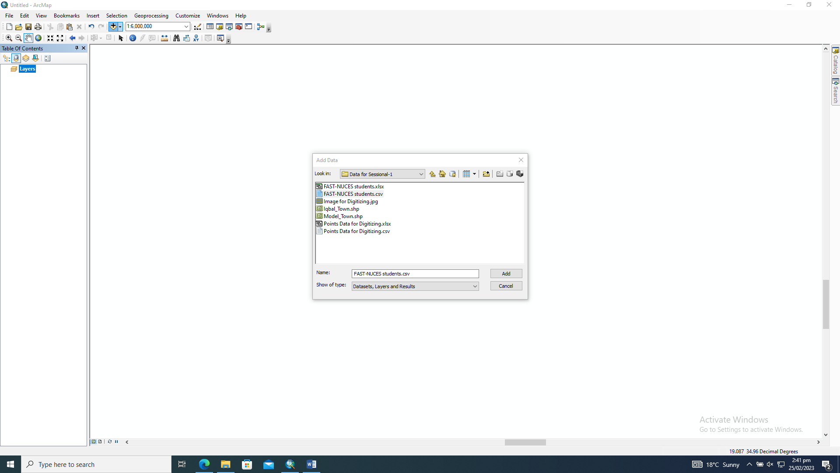

# Display XY data

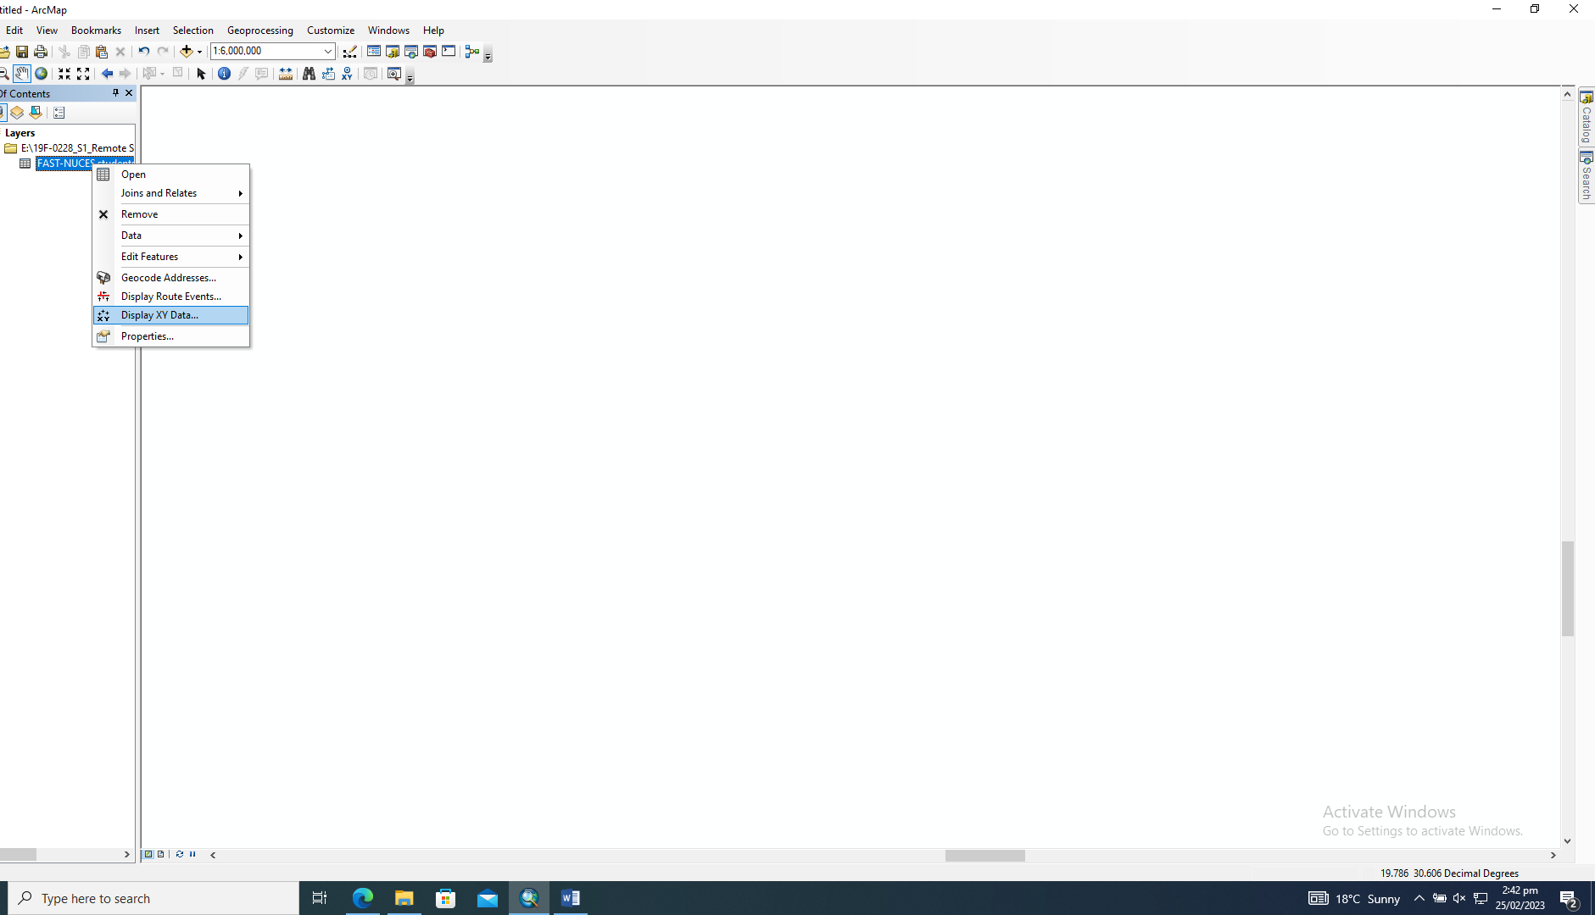

# Setting to 1984 World

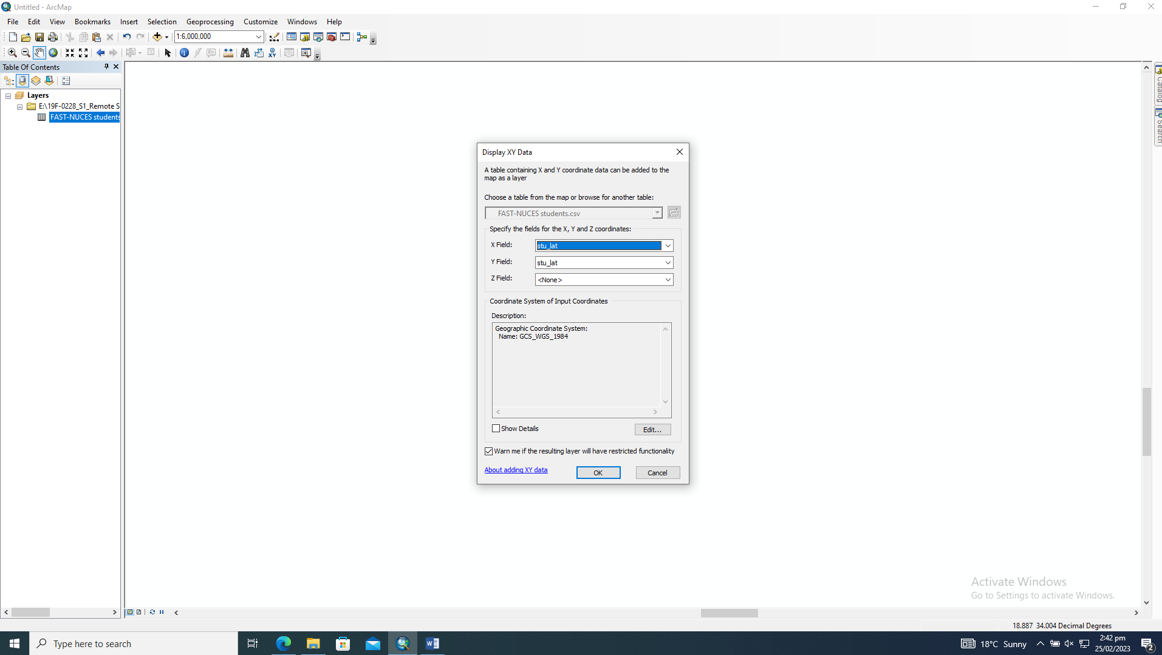

# Zoom to layer

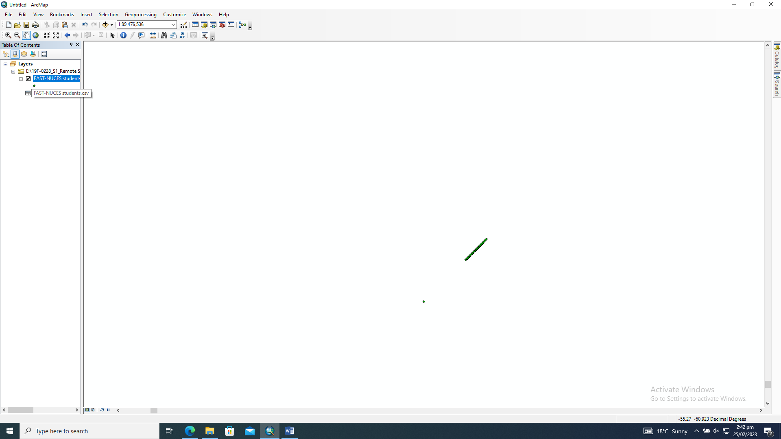

1. Convert the non-spatial data sets of FAST-NUCES Students into shape file.

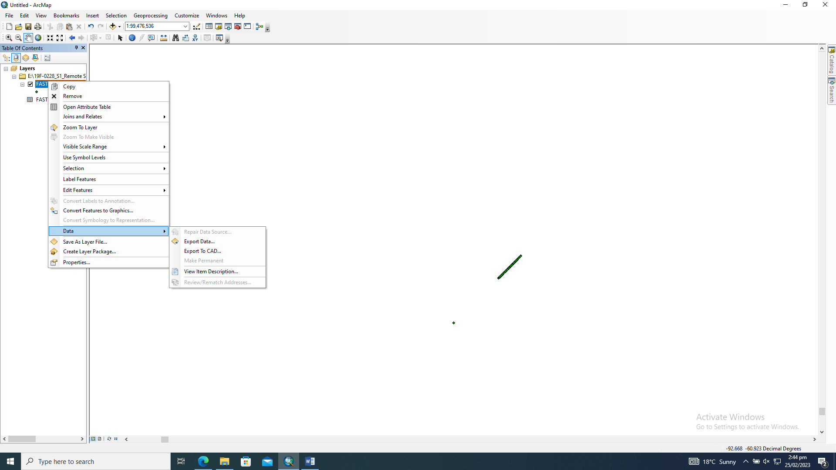

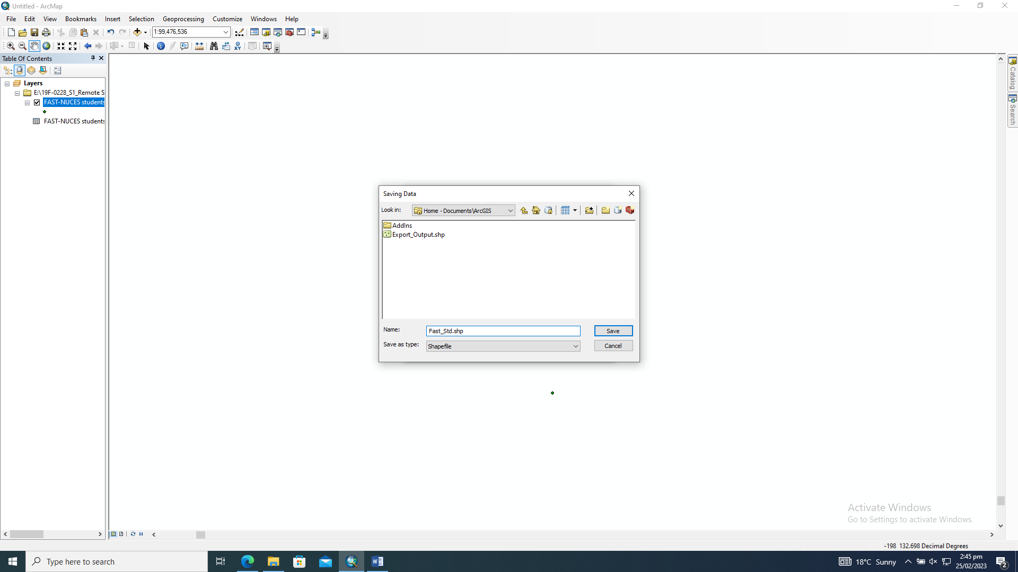

1. Plot the point data set based on the online learning method used by students during COVID-19.

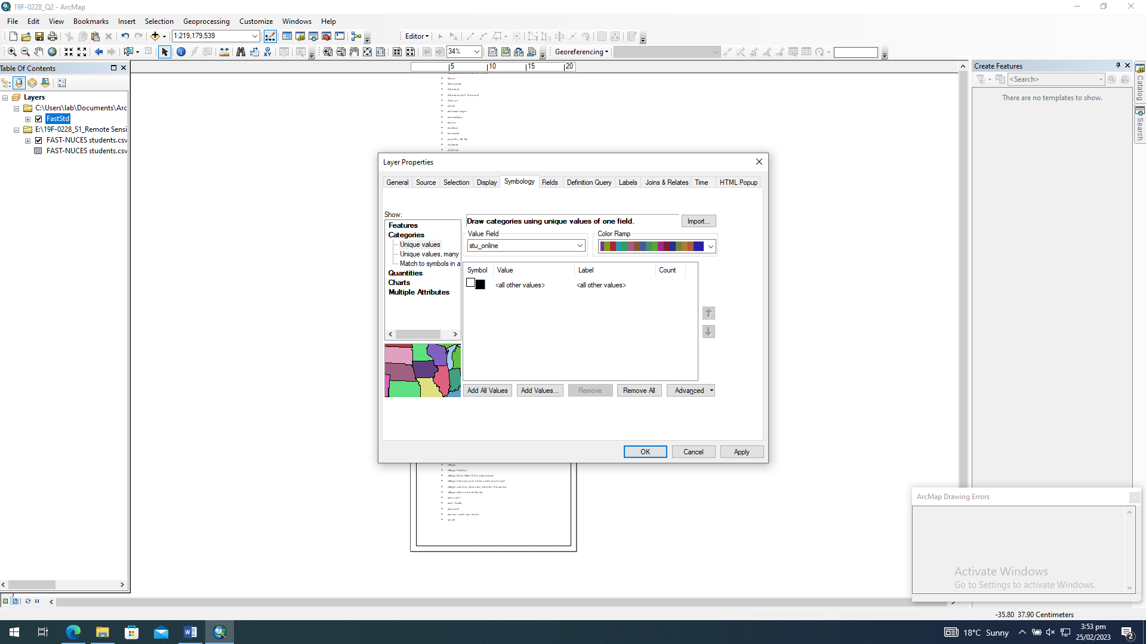

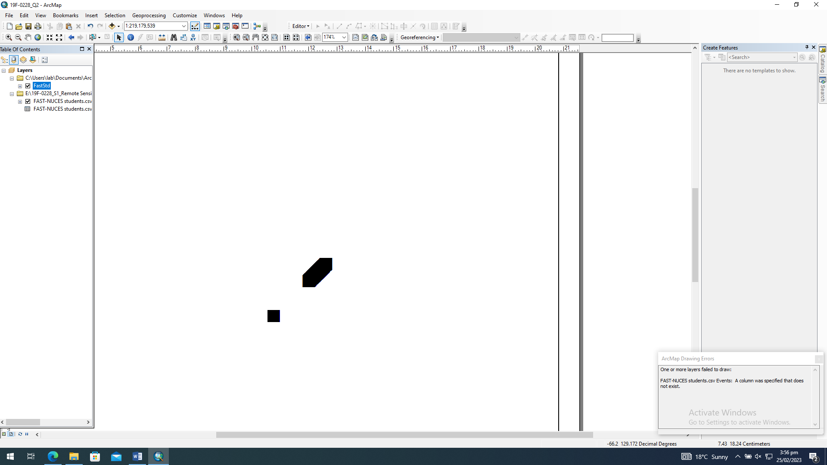

1. Extract and display student’s point those belongs to Model Town.

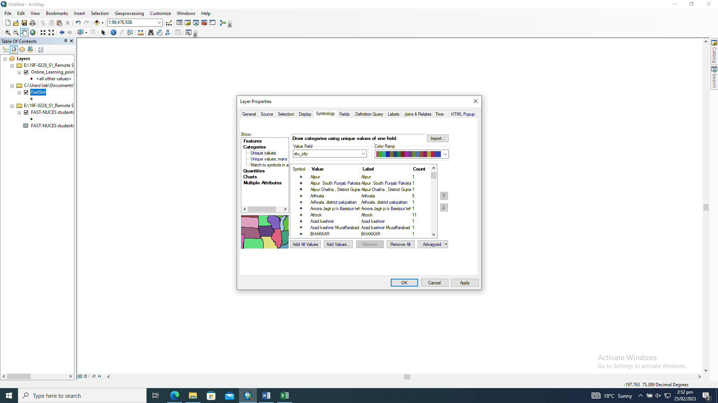

Q3: Geo-referencing and digitizing

1. Add the jpg file “Image for Digitizing” and Geo-refer the image using points marked as circles. Latitude/Long of these points are given in the CSV file.

# Importing Image

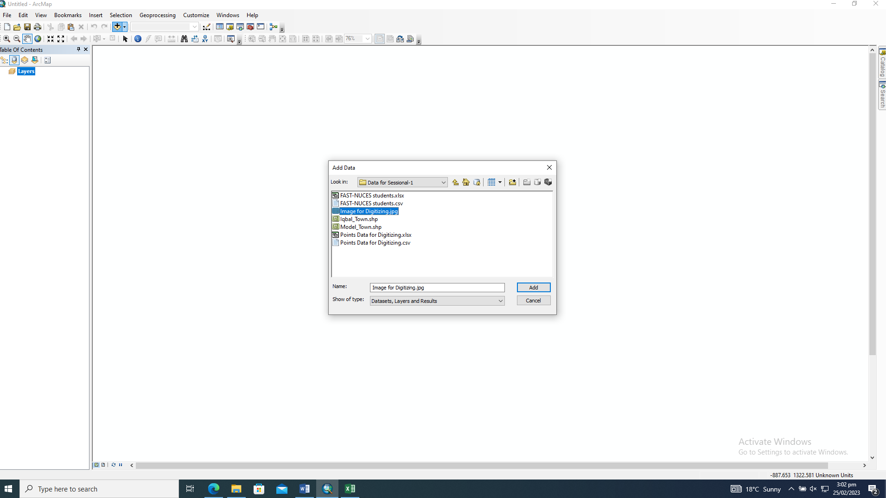

# Selecting Geo Referencing

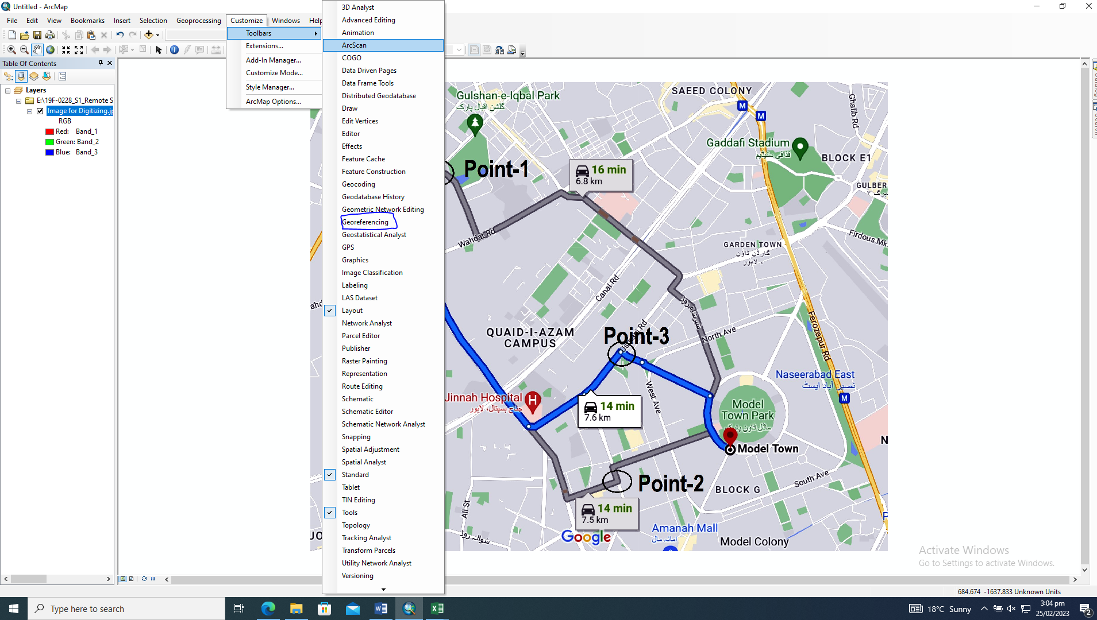

# Marking Point 1

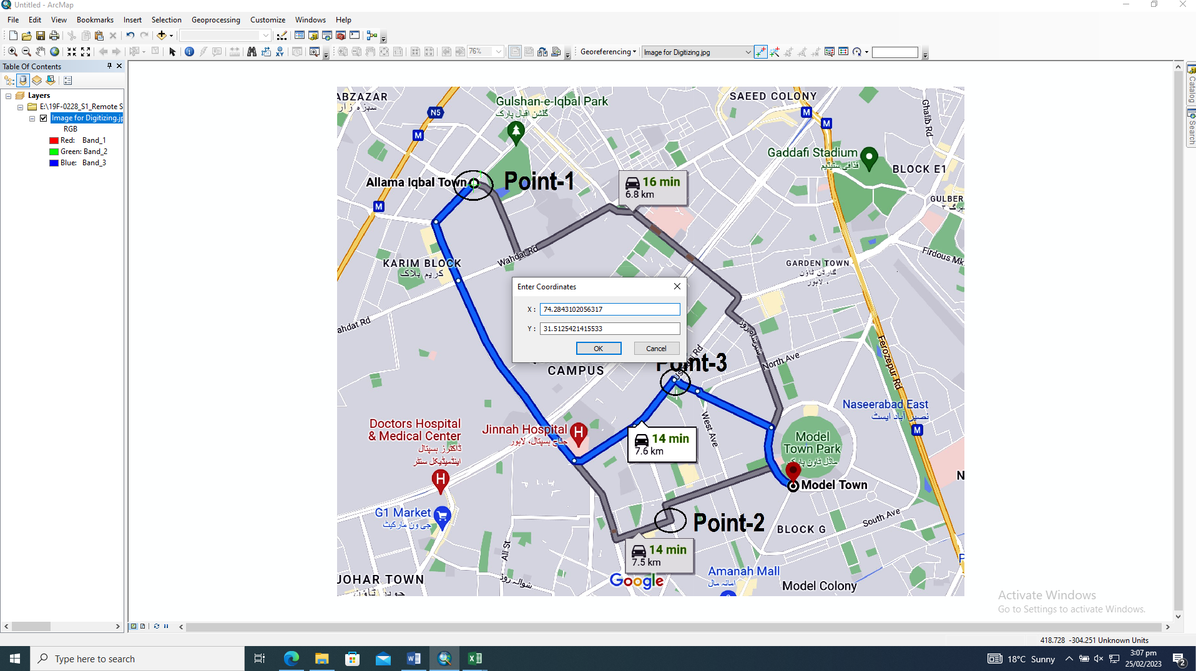

# Marking Point 2

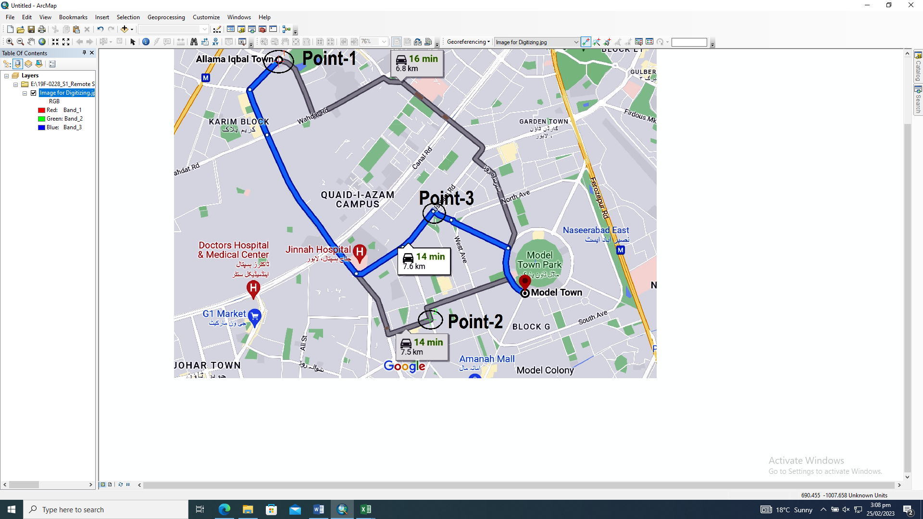

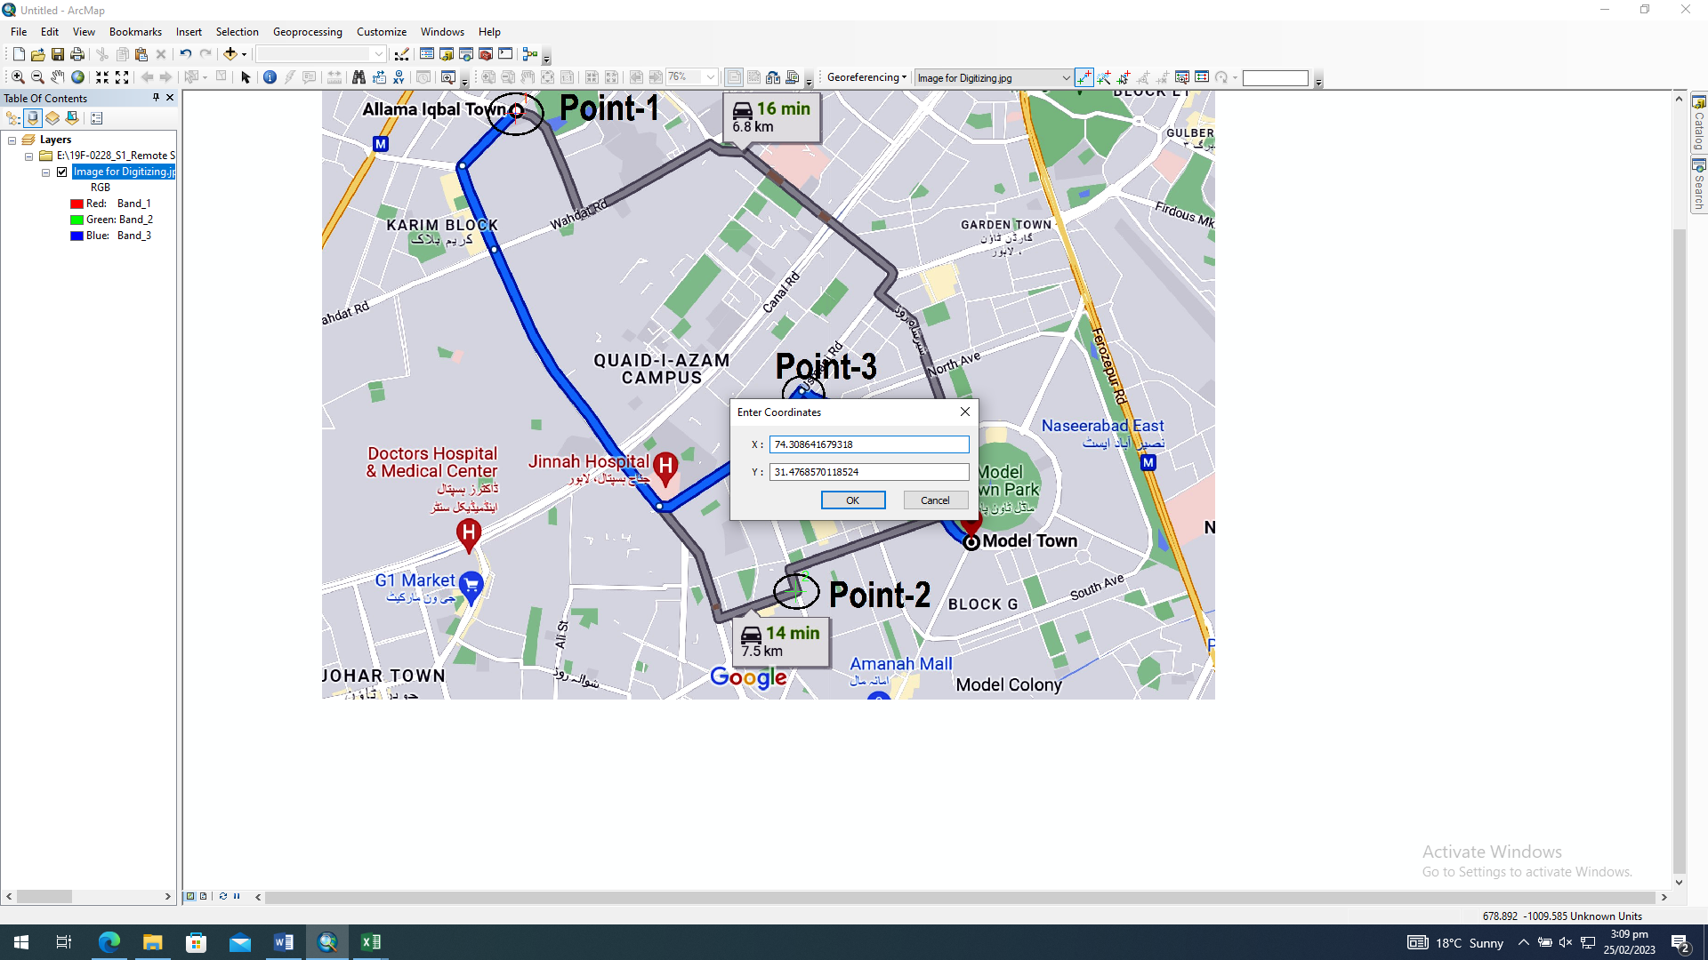

# Marking Point 3

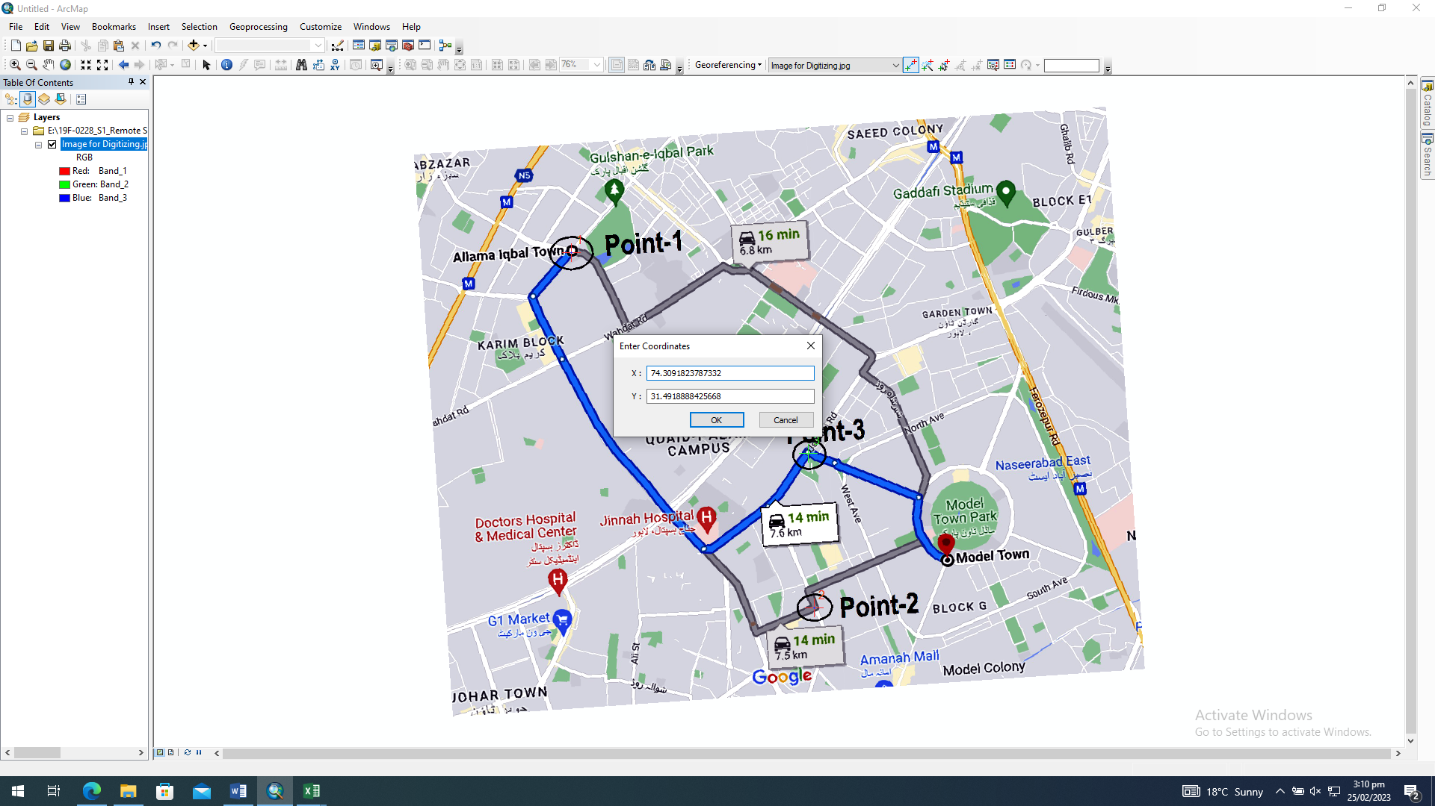

1. Add the shape file of Model Town and Iqbal Town. Create a new shape file of the road and connect both towns using suitable roads.

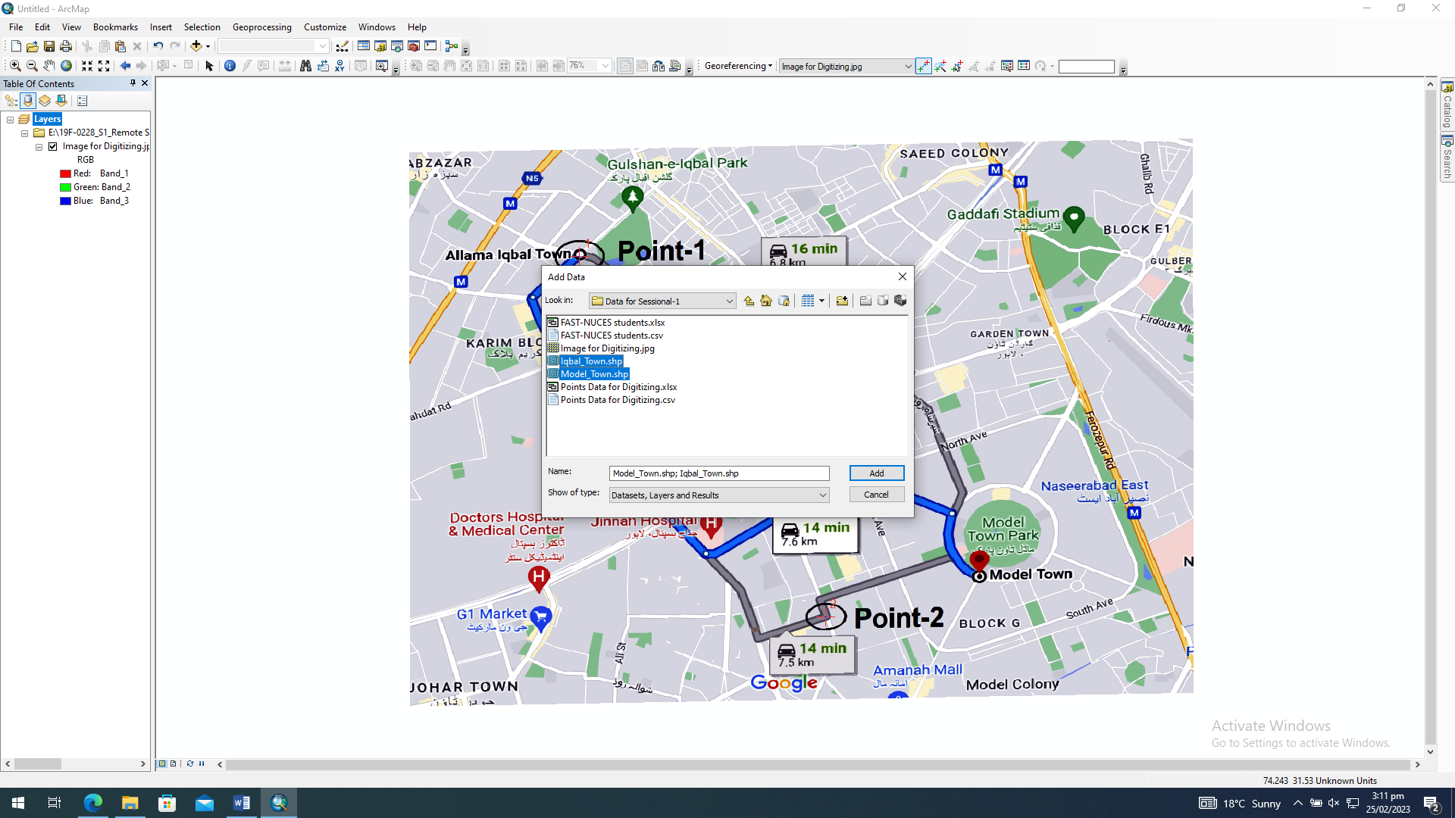

# Creating new shape file:

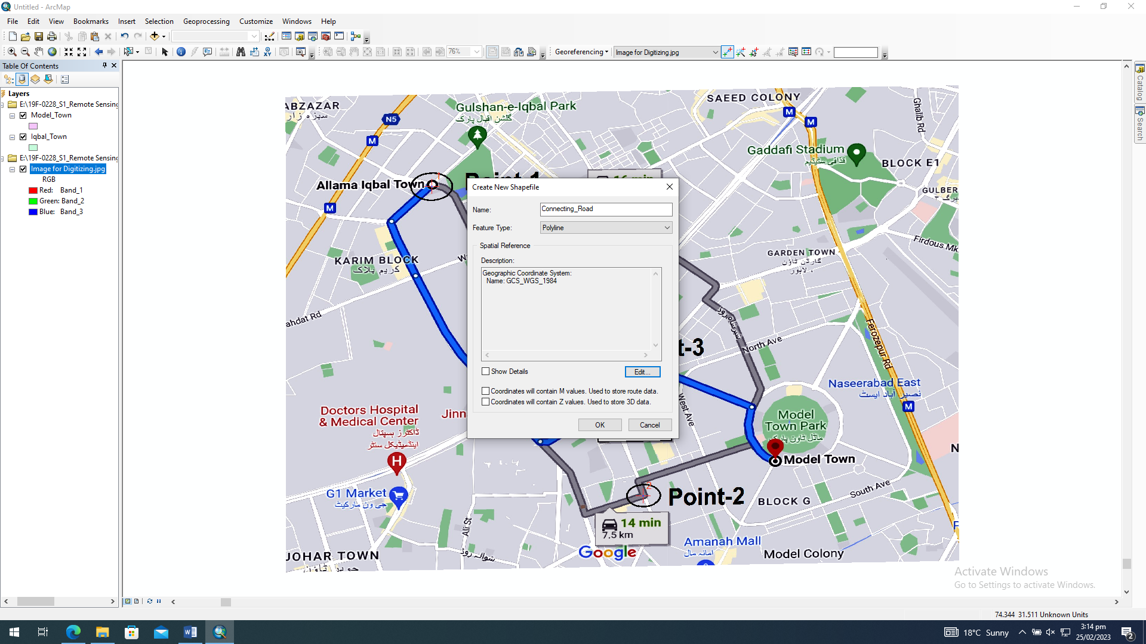

# Start Editing

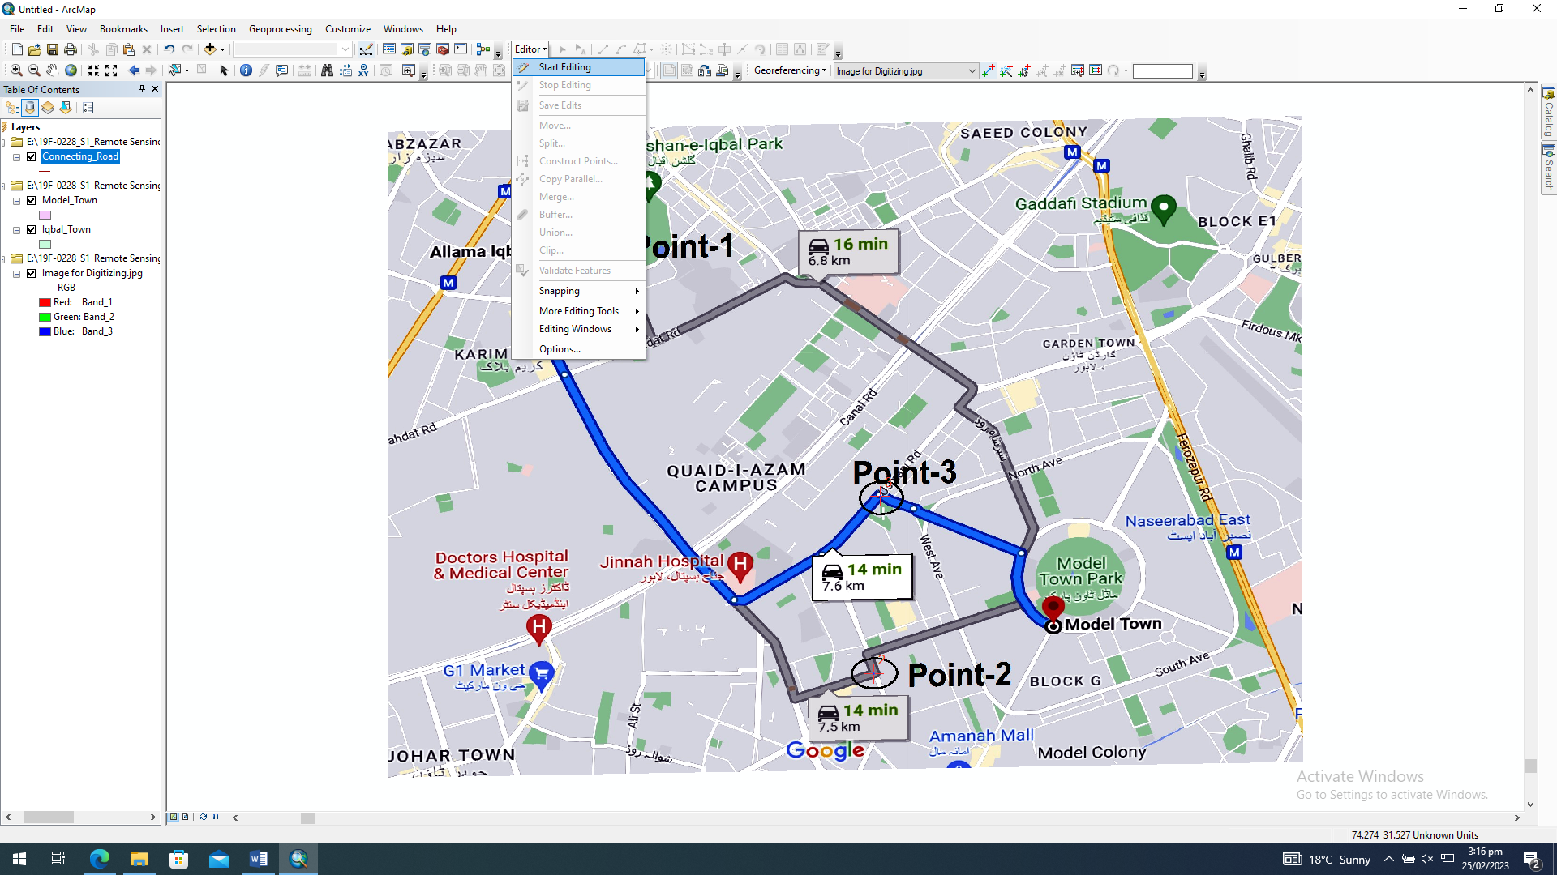

# Adding Name Field for labels

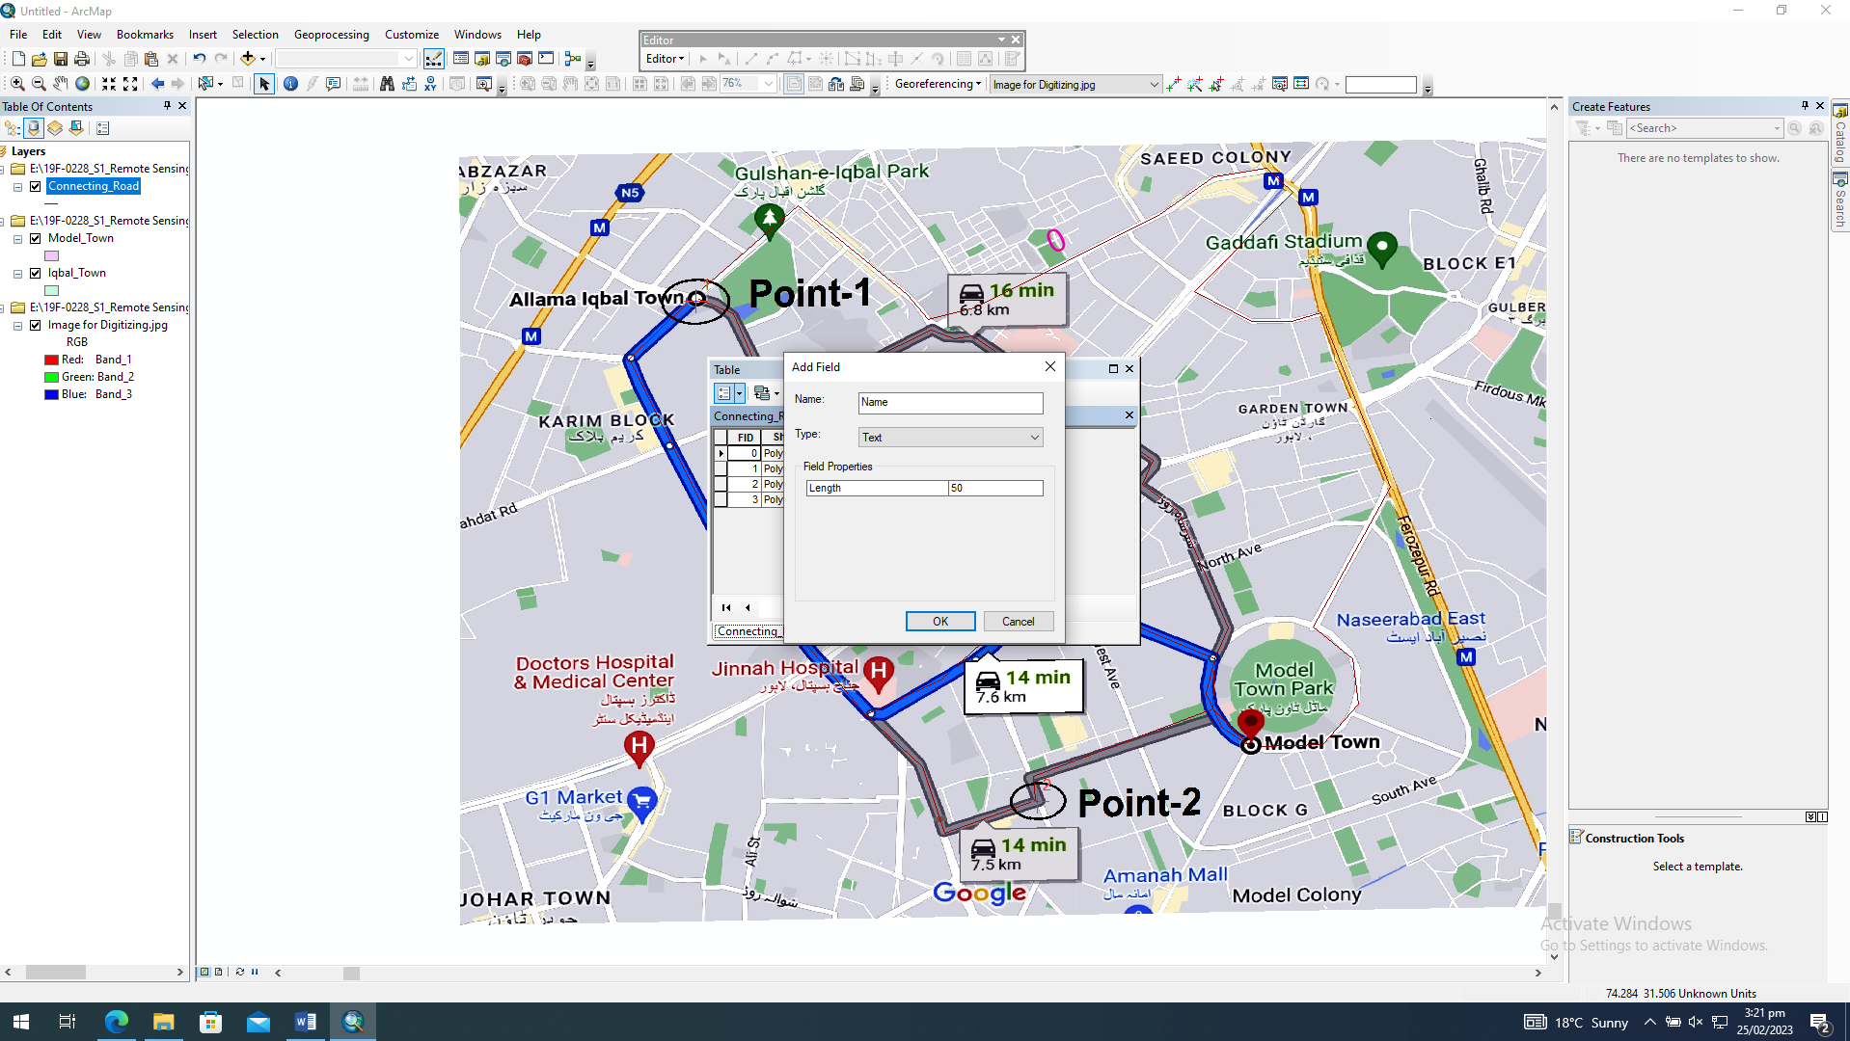

# Adding Attributes Table

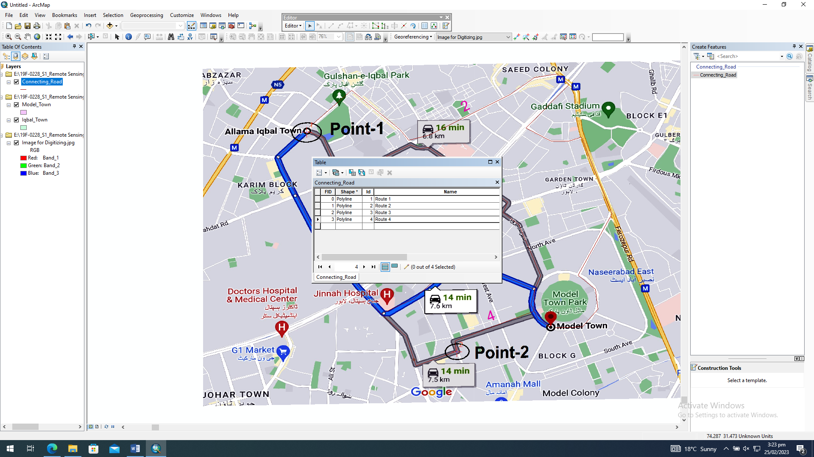

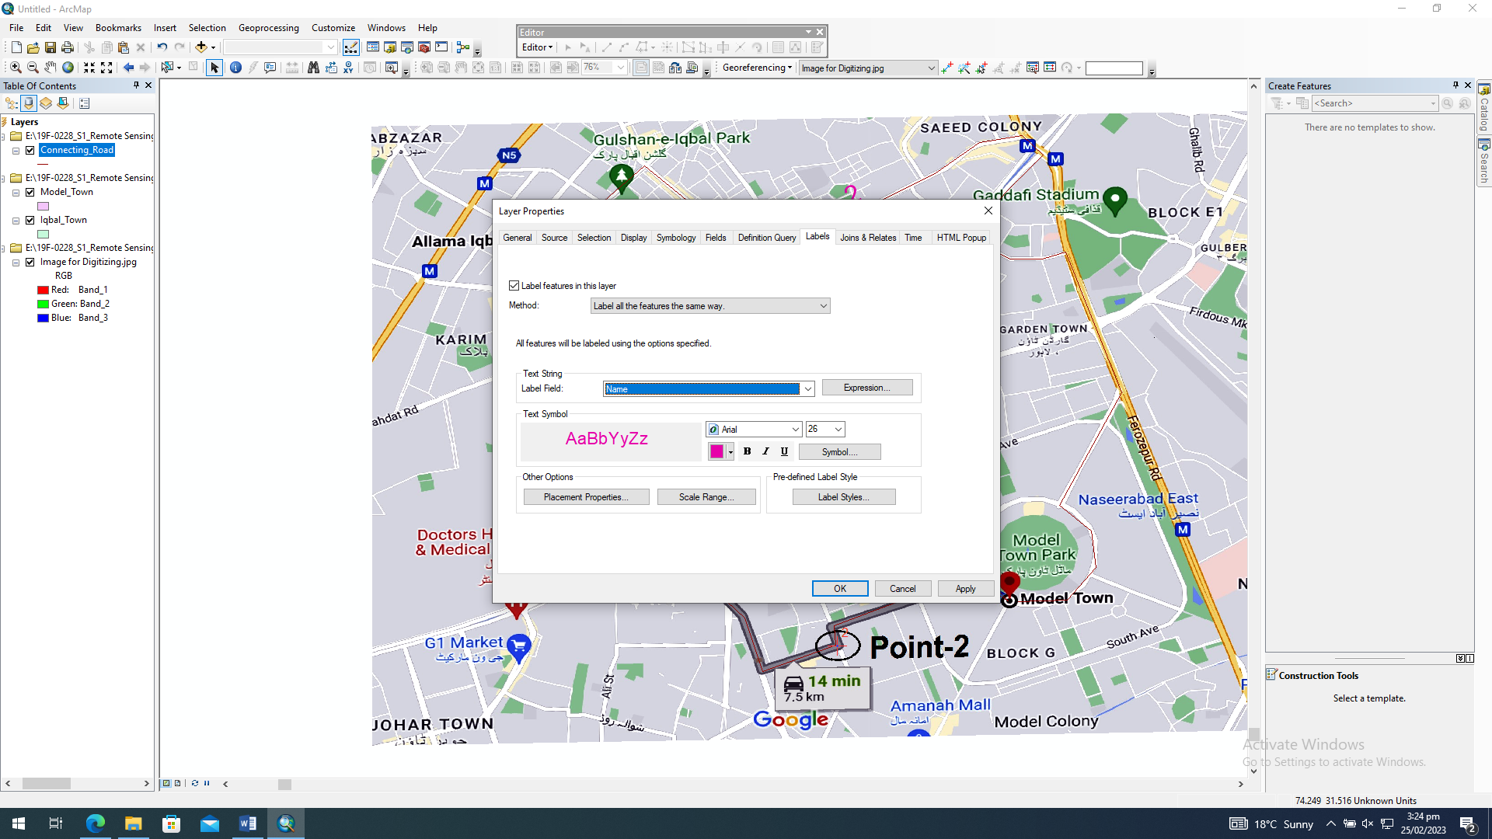

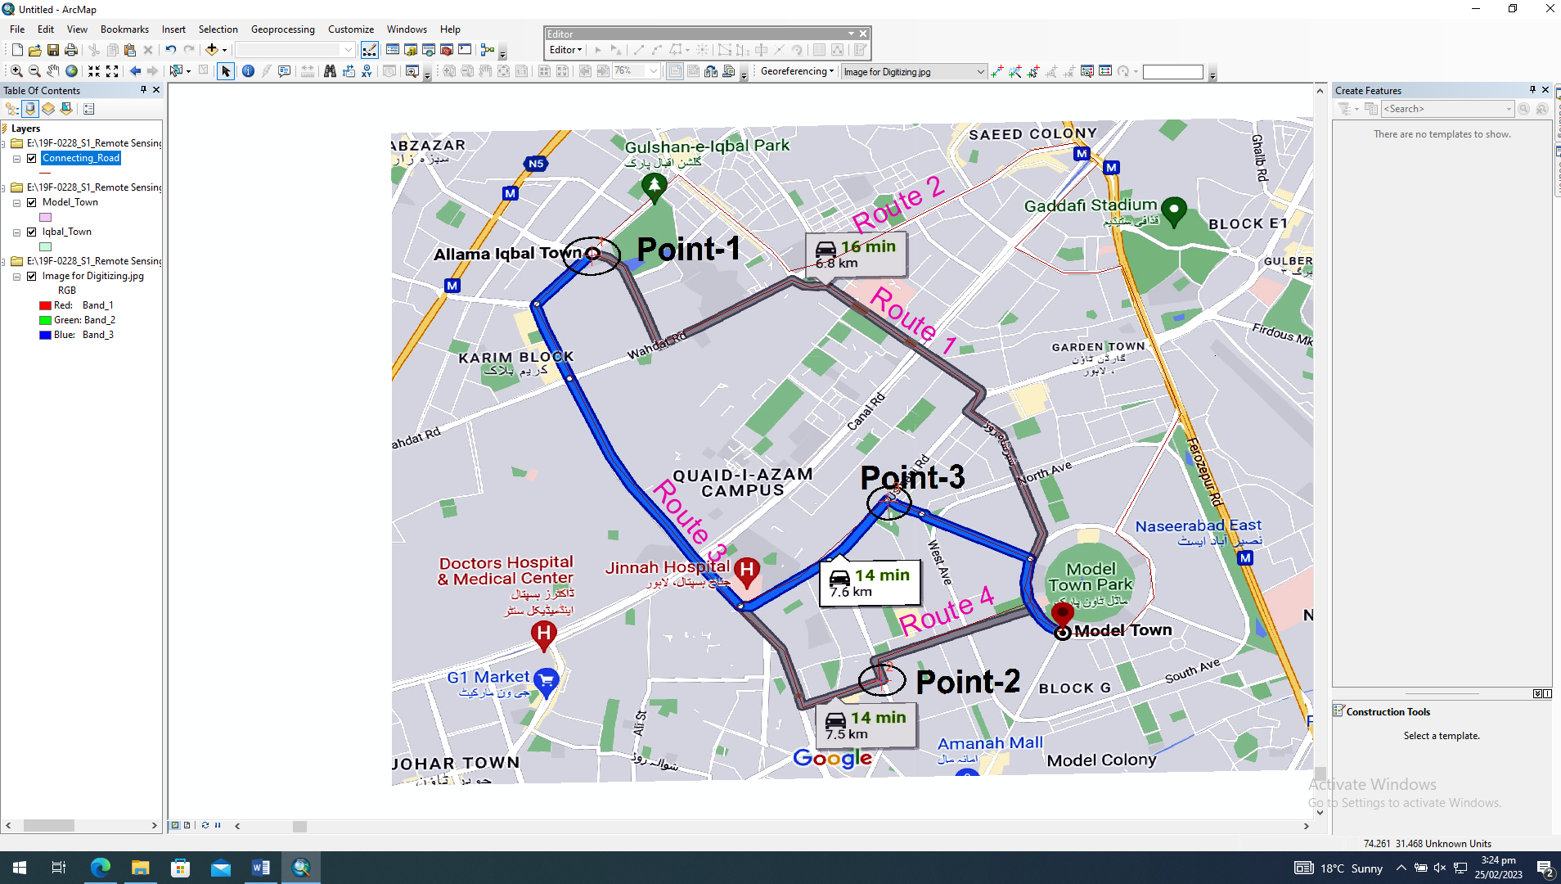

1. Also create the point dataset and mark the two famous hospital names and store its attribute in the dbf file.

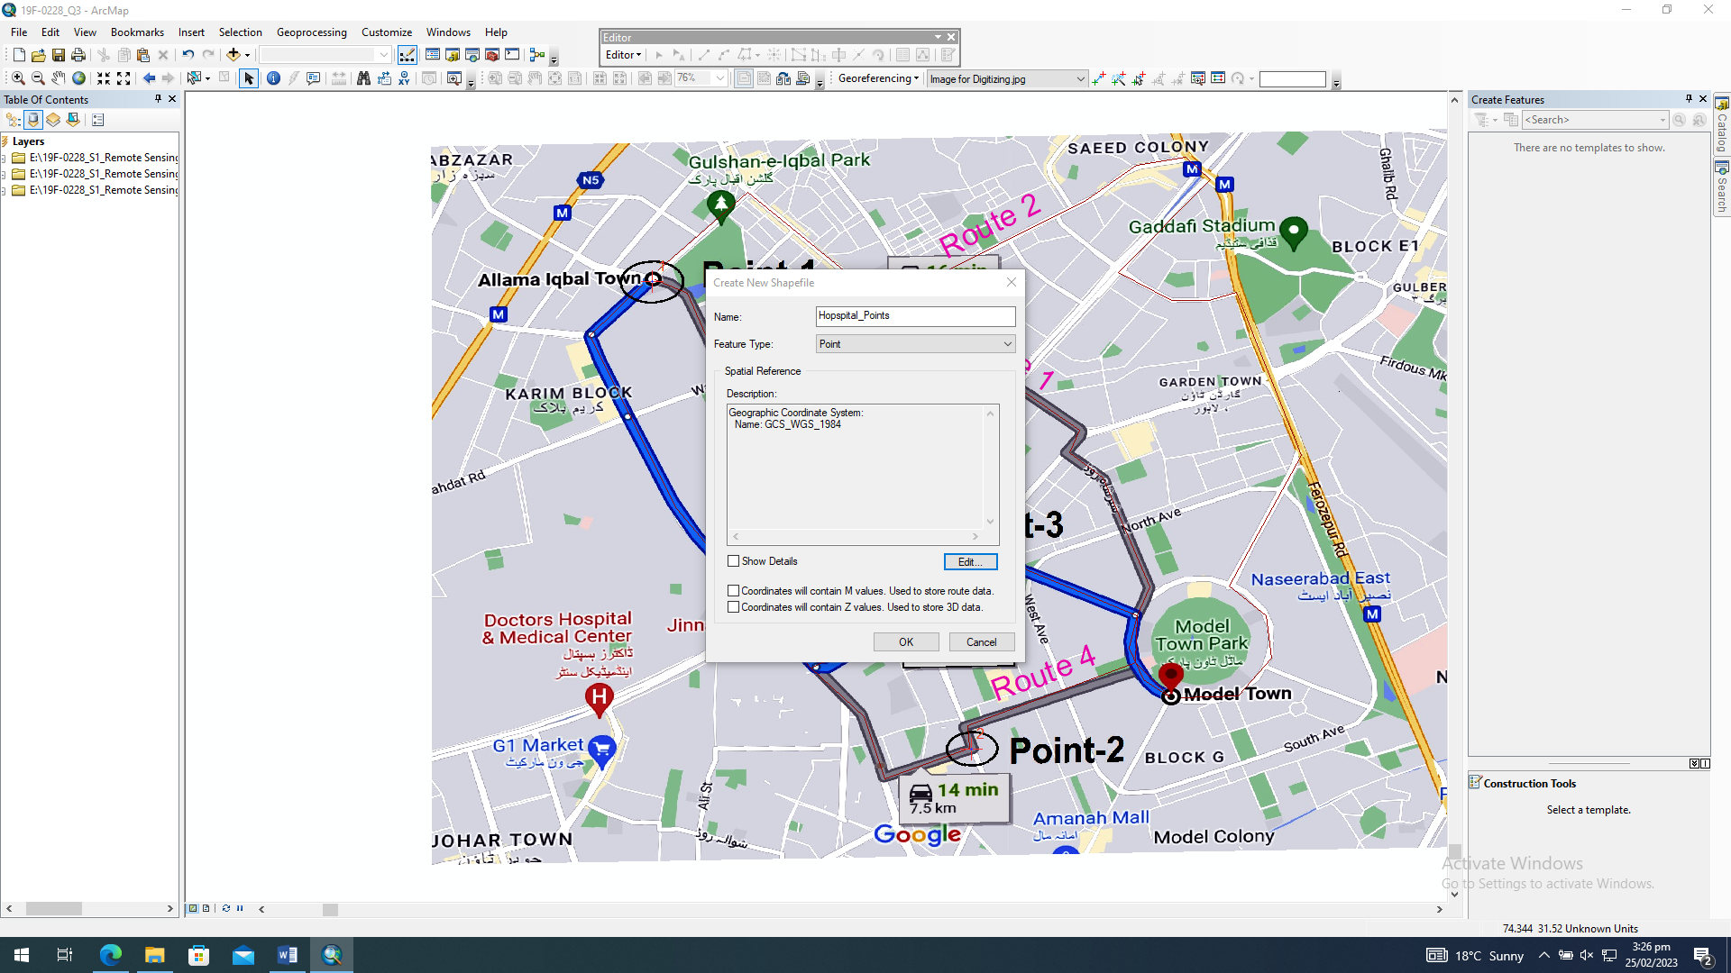

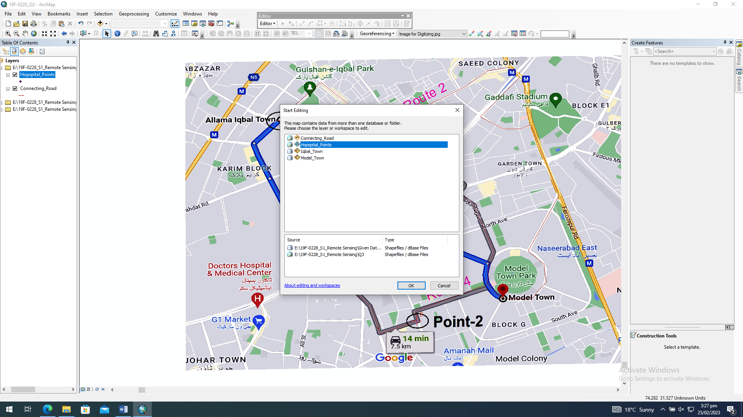

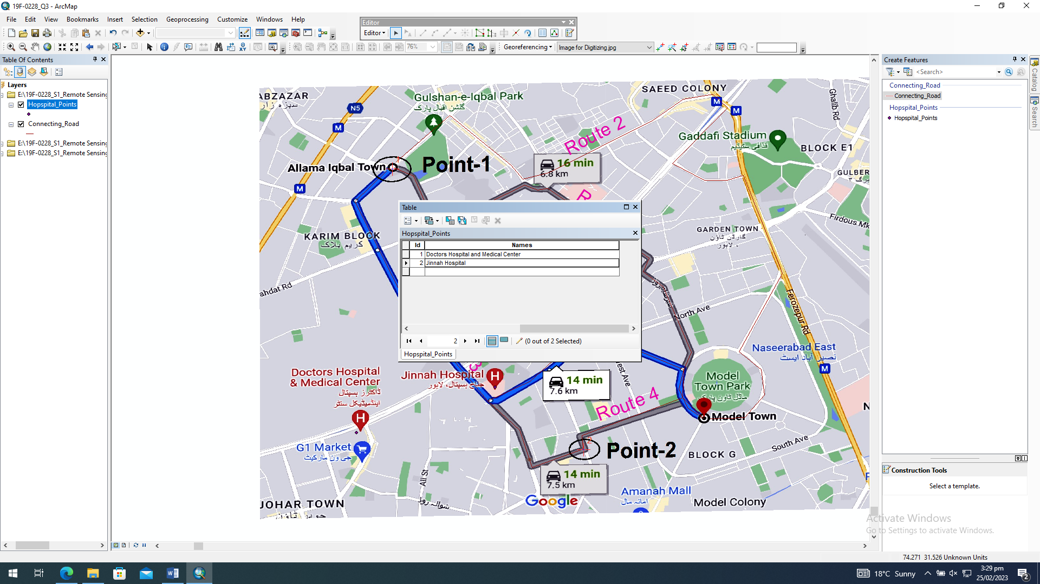

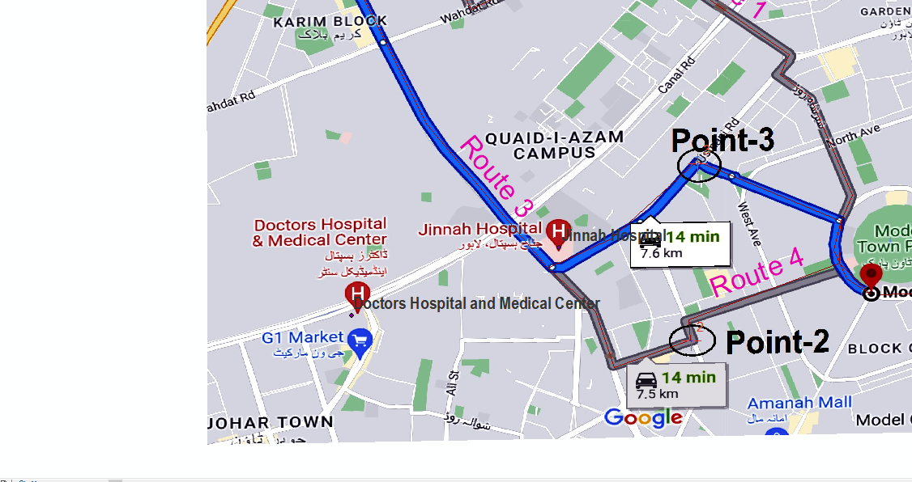

1. Draw the polygon of which is surrounded by both towns.

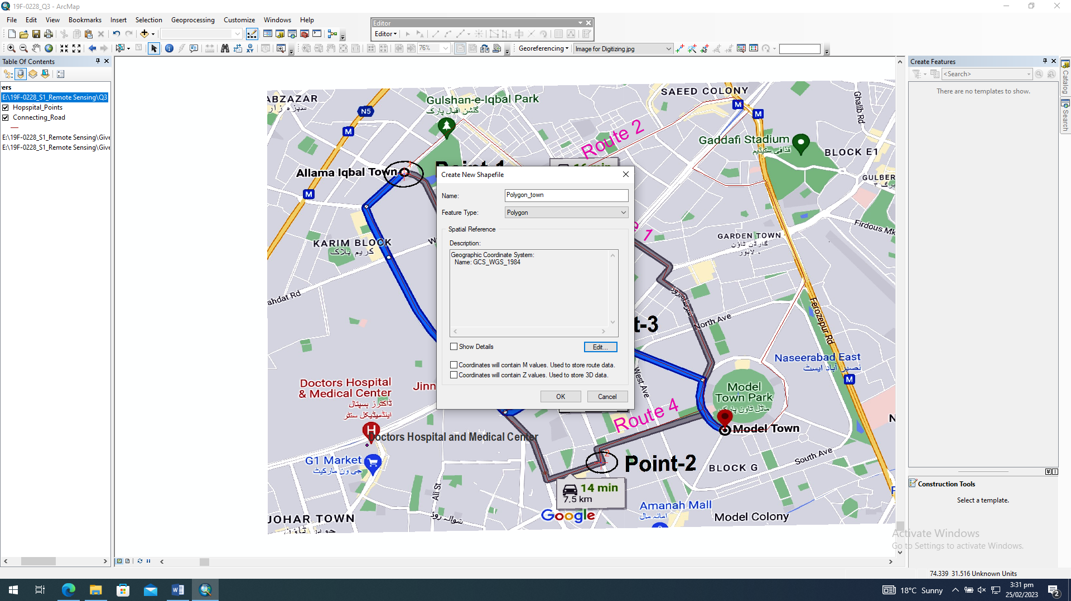

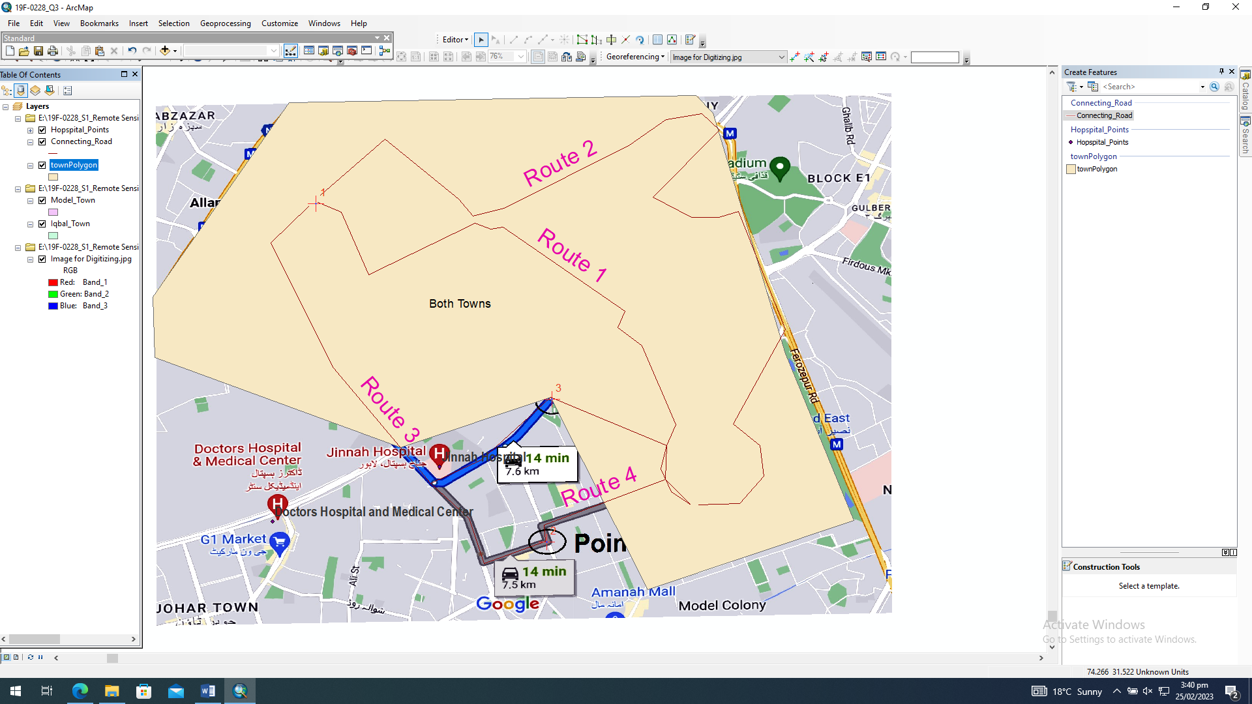

1. Convert the roads into Google Earth readable files.

